​**Call for application for professional accounting training and Practice**

**ACR-Accounting Academy-JUNE-2024-Intake.**

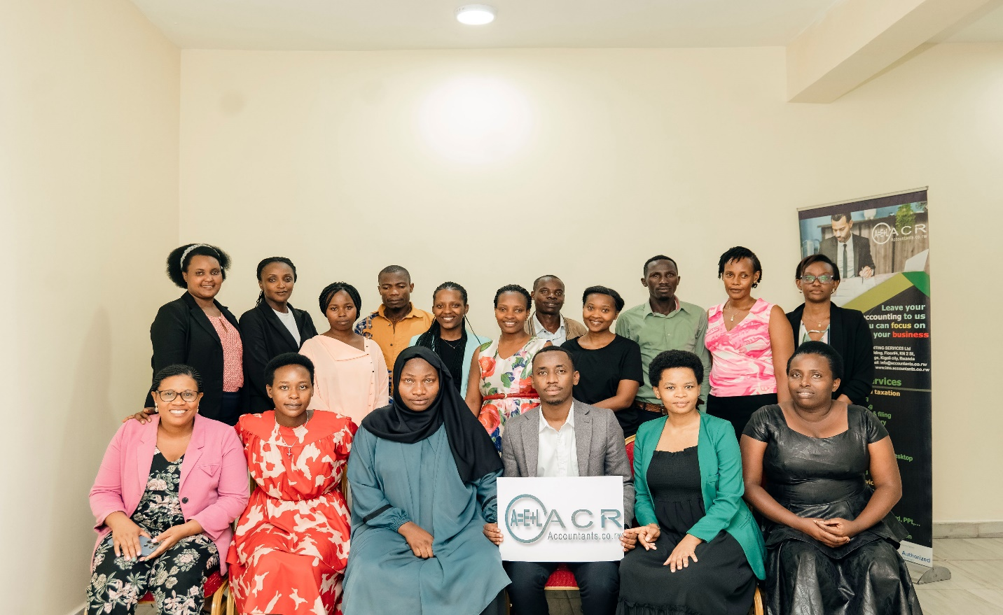

Hello and welcome to the ACR-Accounting Academy! We are overjoyed that you have decided to advance your accounting career with us.

ACR-Online Accounting Services Ltd (ACR) is a Rwandan professional accounting firm that was established in accordance with the Rwandan Company Act. We offer a wide range of outsourced accounting, bookkeeping, tax preparation, and auditing services to Rwandan small and medium-sized businesses.

Since 2019, we have been assisting Rwandan businesses with their accounting needs. We have a thorough understanding of the accounting issues that Rwandan businesses face. As a result, we established [the ACR-Accounting Academy](http://www.lms.accountants.co.rw/apply), a professional accounting training program that combines theory and practice seeking to:

* Prepare you for a career in accounting.
* Prepare you to excel in an accounting role.
* Connect you with employers and recruiters (**85%** of Graduates positioned)

**Learning outcomes:**

This course will prepare you for a career in the accounting industry by covering a wide range of topics. By the end of this course, you should be able to:

* Understand the fundamental accounting concepts and how to apply them in real-world work situations.
* Understand and identify internal controls in accounting and finance processes.
* Know how to use an accounting system (**QuickBooks**) and understand how to enter transactions and run **reports** in an accounting system.
* Be confident in tax preparation and declaration in Rwanda.
* **Read more**

**Targeted person:**

Bookkeepers, accounting technicians, accounting and tax advisors, junior accountants and auditors, consultants, and recent college and university graduates are all appropriate candidates for this course.

**Prerequisites**: A background in accounting or finance is required to join the course.

**Training Calendar:**

**Day Program**

From 03rd to 14th June 2024 ==> Theoretical sessions from 08:30 AM to 02:00 PM

From 17th to 28th June 2024 ==> Practical Sessions 08:30 AM to 05:00 PM

**Evening Plus Saturday Program**

**Theoretical sessions / Weekdays**

From 03rd to 14th June 2024 ==> Theoretical sessions from 05:30 PM to 08:00 PM

**Theoretical sessions / Weekends / Saturdays**

From 03rd to 15th June 2024 ==> Theoretical sessions from 08:30 AM to 02:00 PM

**Practical Sessions / Weekdays**

From 17th to 28th June 2024 ==> Practical sessions from 05:30 PM to 08:00 PM

**Practical Sessions / Weekends / Saturdays**

From 17th to 29th June 2024 ==> Practical sessions from 08:30 AM to 02:00 PM

**Note:** On the last Saturday of the month **/ Umuganda Day**, the training starts from 2:00 pm to 6:00 pm

**Training Venue:** Gisozi, KG 14 Ave, GJK Building, 1st Floor, Near Kigali Genocide Memorial.

**What to expect during the training?**

**ACR will provide you.**

* A copy of QuickBooks Desktop for training use only
* Computer Desktop (Optional)
* Free internet access (Wi-fi)
* Training Materials (soft copy)
* Breakfast, after lunch snacks and coffee**🥣**
* Lunch is only provided during the Practice or fieldwork period for the day program.

**Requirements**:

1. Registration (No cost)
2. Training fees **Rwf 200,000 (For Day program and Evening plus Saturday program).**

**Terms of Payment**

**Bank Details**

**Beneficially Name: ACR-Online Accounting Services LTD**

------------------

1. **Bank Name: Equity Bank Rwanda**

Account Number: 4002200956750 (RWF)

--------------------------------

1. **Bank Name: BPR Bank Rwanda**

Account Number: 4491074070 (RWF)

---------------------------------

1. **Mobile Money**

* MOMO Pay **098221**-ACR-Online Accounting Services

1. **Cash**

* Visit us at Gisozi, KG 14 Ave, GJK Building, 1st Floor, Near Kigali Genocide Memorial from 09h00 to 16h00.

**Lessons**:**Lesson 1 – Accounting fundamentals #1**:  
Learn about the elements of financial statements.

**Lesson 2 – Accounting fundamentals #2**:  
Learn about transactions, journal entries, debits, and credits.

**Lesson 3 – Accounting fundamentals #3**:  
Become a debit and credit expert by learning about advanced accounting transactions.

**Lesson 4 – Cash receipts process:**  
Learn about the cash receipts process. When a company receives payment, how do we account for it?

**Lesson 5 – Cash disbursement process:**  
Learn about the cash disbursement process. When a company makes a payment, how do we account for it?

**Lesson 6 – Bank reconciliations:**  
Learn about the bank reconciliation process but more importantly, learn how to perform a bank reconciliation.

**Lesson 7 – Month-end processes:**  
What happens at the end of the month for the accounting team? In this lesson, we learn about the month-end procedures.

**Lesson 8 – Taxation**:  
Learn about the different taxes that impact companies in Rwanda: corporate income tax, VAT, withholding, district taxes, and payroll deductions plus the basic skills on how to use EBM invoicing software.

**Lesson 9 – Excel:**  
An introductory course to Excel. Learn how to format tables and analyse data using formulas, functions, pivot tables, and VLOOKUPs.

**Lesson 10 – Accounting software:**   
*(QuickBooks Online,* ***QuickBooks Desktop****,* Learn the basics of QuickBooks Desktop. Enter invoices, bills, and journal entries and run reports, just like you’ll need to do at your job!

[**Click here to see the full course contents**](https://bit.ly/3zY7yvu)

**Certificate of Completion:**

You will receive a certificate of completion once you have completed the entire course (Theory and practice) and passed **80%** in the course final exam.

**Registration**: [Click here to apply](https://bit.ly/3bBoCxV)

**Note that your name must be the same as appears on your official identification documents.**

---------------------------------------------------------------------------------------------------

**Graduates-Testimonials**

1. [Marie Therese NYIRANZIGIYE](https://www.google.com/maps/contrib/108432363404815337468/reviews?hl=en-US)

*Learning accounting at school is not enough! "ACR-Online Accountant " specialized in providing the necessary: (Basic accounting and practical skills) in just one month….* [Read More](https://g.page/r/CSrWLds3258GEAg/review).

1. [Armel Mugisho](https://www.google.com/maps/contrib/106844013151376043017/reviews?hl=en-US)

*ACR offers the best accounting service to Enterprises, Professionals, Students, and any other individual eager to learn or improve their accounting skills! I experienced it and I suggest you try it too! Thanks!*

1. [Kakine Tuyizere](https://www.google.com/maps/contrib/110960569651475111327/reviews?hl=en-US)

*Hello, ACR helped me to build my career in the accounting field by training us on accounting skills, tax declaration, and different accounting software used in accounting. Thank you for the good services.*

Check out the latest feedback from our graduates on [Google reviews](https://g.page/r/CSrWLds3258GEAg/review)

**Contact us**

* Telephone: +250788685947
* E-mail : [info@accountants.co.rw](mailto:info@accountants.co.rw)
* Web: <https://lms.accountants.co.rw/appy/>
* [Facebook](https://web.facebook.com/Accountants.co.rw/) | [WhatsApp](https://bit.ly/3RpfPP2) | [LinkedIn](https://www.linkedin.com/company/accountants-co-rw/) | [Twitter](https://twitter.com/AccountantsRw) | [Instagram](https://www.instagram.com/acraccountingfirm)

Address: Kigali city, Gisozi, KG 14 Ave, GJK Building, 1st Floor, Near Kigali Genocide Memorial.

* **Google location**

Find us on [Google map](https://goo.gl/maps/mPPHH38vLZBdV1AFA)

​